çizim, taslak, kırpıntı çizim, grafik içeren bir resim

Açıklama otomatik olarak oluşturuldu

ARTIFICIAL INTELLIGENCE AND LAW

[ŞEYMA DOĞAN 2230765034] [FATMA KARACA 2220765024]

07 Aralık 2023

HACETTEPE ÜNİVERSİTESİ YAPAY ZEKA MÜHENDİSLİĞİ

**ARTIFICIAL INTELLIGENCE AND LAW**

***Abstract—****This report examines the impact of artificial intelligence on document analysis, document creation, and legal predictions in the field of law. Artificial intelligence optimizes document analysis and creation processes, allowing legal professionals to save time and effort. Particularly, AI excels in swiftly scanning large datasets for document analysis and retrieving relevant information faster and more accurately than humans. Additionally, AI automates document creation tasks, enabling legal professionals to dedicate more time to complex matters. In legal predictions, AI streamlines decision-making processes, reduces risks, improves time management, and enhances communication. It can analyze past legal trends and forecast future outcomes, aiding legal professionals in making informed decisions about litigation strategies, settlements, and other legal matters. AI applications such as Evisort, ROSS Intelligence, Adalethanım, and Luminance assist in legal research tasks. These platforms handle duties like drafting contracts, answering legal queries, and identifying crucial provisions in contracts. Similarly, AI-powered document creation platforms like Perfect NDA, LegalMation, Specifio, and LawGeex automate tasks such as preparing NDAs, creating litigation documents, drafting patent applications, and verifying contract compliance. These examples illustrate just a few ways AI is transforming the legal landscape. As AI technology continues to advance, we anticipate the emergence of more innovative applications, further enhancing the efficiency, accuracy, and accessibility of legal services.*

**1.INTRODUCTION**

Law is a fundamental cornerstone in maintaining order within societies. Technological advancements have significantly showcased the impacts of artificial intelligence in the realm of law. The concept of "Artificial Intelligence and Law" represents the application of computer and mathematical techniques to make law more understandable, manageable, useful, accessible, or predictable. Its origins trace back centuries, with early thinkers like Gottfried Leibniz exploring how mathematical formalisms could enhance legal systems. Since the mid-20th century, computer science and artificial intelligence have begun to find utility in law. Research in AI and law often parallels broader AI studies, frequently focusing on knowledge representation and rule-based legal systems. Much of this research originates from European-based university laboratories, concentrating between the 1970s and 1990s on modeling legal debates in computable formats and algorithmically handling legislative and legal rules. The International Conference on Artificial Intelligence and Law (ICAIL) has been showcasing applications of AI in law since at least 1987. Among the pioneers and successful researchers in this field, there are several well-known names that frequently come up in discussions. From the early 2000s onwards, there's been a shift towards machine learning-based approaches in AI and law, departing from knowledge representation techniques. Many recent applications aim to make law more effective or efficient using machine learning, often emerging from legal tech startup companies. Advances in AI and law have emerged from interdisciplinary university centers, and as a result, AI-supported computer systems have slowly integrated into various facets of legal systems. Complex processes within law, such as document analysis, examining case files, and document generation, have demonstrated potential for optimization using artificial intelligence. This technology can analyze large datasets, categorize documents, and understand legal texts, potentially enhancing efficiency within legal practices. This report delves into the impacts of artificial intelligence in the field of law and explores the opportunities presented by this technology [1].

**2. DOCUMENT ANALYSIS AND DOCUMENT CREATION**

**2.1 Document Analysis**

An exemplary instance where artificial intelligence is applied in the realm of law emerges in the field of document analysis. This involves the detailed examination, interpretation, and processing of legal documents using advanced technological algorithms. Such an approach aims to optimize decision-making processes and information retrieval within legal frameworks. Presently, legal professionals can access sample cases and legal regulations in a virtual environment by inputting specific keywords, enabling swift access to desired data without the need for extensive scanning through books and documents. Software developed within the subset of artificial intelligence known as Natural Language Processing (NLP) provides the opportunity for detailed analysis of tagged legal data. These programs facilitate tasks like file categorization and summarization of petitions or reports. Consequently, they offer time and energy savings for professionals in the legal field. Furthermore, in simple legal procedures, accessing information through software platforms eliminates the necessity of visiting legal offices [2].

Legal practitioners can benefit from technology in areas such as contract analysis, document review, and e-discovery through AI-based applications used in this field. A contract between two parties defines the scope of work and commercial terms for carrying out activities. Reviewing and analyzing the contract, assessing risks such as liability, indemnity, risk procurement, and similar commercial risks, is crucial for any business organization. Early identification of these risks assists in either reducing them or making an informed decision about entering the contract considering the risk-reward ratio. Traditionally, organizations rely on manual reading by legal professionals to assess risks arising from documents. However, the continuous flow of legal documents demands more time and expertise for review. This time-consuming and person-dependent activity is both cost-intensive and inefficient. Despite investing 11.2 hours per week in document creation and management, the risk of errors remains due to unidentified or misinterpreted risk elements, which could impact an organization's performance and increase financial risk. Therefore, there's an increasing demand for intelligently analyzing contracts and other legal documents, providing accurate interpretations with minimal human intervention. This goes well beyond a simple "contract management system" that merely files and indexes electronic contracts or legal documents. An efficient contract analysis system capable of identifying and highlighting embedded risks in contracts or other legal documents not only saves time but also minimizes risks [3].

When a comprehensive examination of extensive document sets is necessary, artificial intelligence can automatically classify documents and highlight key information. This process can assist law firms or companies in managing their documents more effectively. Particularly, the review of document content and the identification of key elements can be conducted more efficiently using the automatic classification and highlighting capabilities offered by artificial intelligence.

Electronic discovery, also known as e-discovery, refers to a digital investigation process involved in obtaining and sharing evidence in legal cases. This process is utilized to find evidence in emails, business communications, and other data. It is employed when involved parties need to provide records and evidence related to a lawsuit. The secure acquisition and exchange of electronic data are carried out for the purpose of using it as evidence. Each firm can conduct e-discovery on a specific computer or network using its own procedures. The data collected during the e-discovery process encompasses all types of information in electronic format, such as emails and social media posts. E-discovery consists of a series of steps including identification, preservation, data collection, review, analysis, converting physical assets into documentation, and presenting them to the user through specialized software. The rapid increase in the volume of electronic documents today aids courts compared to manual document searches, allowing for more accurate outcomes. Artificial intelligence applications are frequently used throughout all stages of the e-discovery process, yielding highly beneficial results. For instance, Luminance, introduced in the United Kingdom in 2016, employs pattern recognition technology, advanced statistical probability analysis, and supervised/unsupervised machine learning methods in reviewing legal documents [4].

**2.2 Document Creation**

Traditional legal practice conducts document creation processes through manual procedures, but with the advancement of artificial intelligence (AI) technology, significant changes are occurring in these processes. Artificial intelligence enhances efficiency in document creation processes within the legal field and transforms the working methods of legal professionals.

Natural Language Processing (NLP) algorithms and learning techniques constitute the foundation of artificial intelligence-based document creation systems. These systems stand out for their capability to analyze intricate legal texts and generate meaningful content. Particularly, these technologies enable document creation processes to be conducted more swiftly, accurately, and effectively.

Legal document creation systems supported by artificial intelligence utilized by law firms possess the ability to automatically scan and summarize vast volumes of legal documents, as well as associate them with specific keywords. These systems optimize the document creation process, facilitating comprehension of legal texts and resulting in time efficiency. Neota Logic's Perfect NDA tool leverages the company's artificial intelligence (AI) platform to simplify the creation process of confidentiality agreements. LegalMation uses AI for automating the generation of various documents related to defenses and discovery requests in lawsuits. Wevorce and Hello Divorce automate divorce processes through AI. Allstate employs AI to automate the creation of claim summaries. In the United Kingdom, Keoghs has developed a series of AI-supported systems for personal injury claims. In patent prosecution, Specifio's AI-based software automatically prepares the initial draft of a patent application from a set of prompts provided by the user. CLOEM S.U.S.A. generates variants of input prompts to assist those preparing patent drafts in accurately defining the scope of their inventions [5].

Ultimately, AI-powered document creation processes represent a significant transformation in the legal field. These technologies reduce the workload of legal professionals while enhancing efficiency and accuracy. It is expected that these technologies will be even more widely used in legal practice in the future.

**2.3 Artificial Intelligence Supported Legal Applicationsmetin, yazılım, bilgisayar simgesi, web sayfası içeren bir resim

Açıklama otomatik olarak oluşturuldu**

In the field of law, various AI-based software is used for document analysis and document generation. "Kira Systems" software can perform a more accurate situation assessment and contract review by searching, highlighting, and compiling relevant content for analysis. It claims to complete tasks from 40% up to 90% faster depending on the user's experience.

**metin, yazılım, web sayfası, bilgisayar simgesi içeren bir resim

Açıklama otomatik olarak oluşturuldu**

The LEVERTON division of the German-based AI Institute uses AI technology to extract relevant data, manage documents, and compile leases for real estate transactions. It's stated that this cloud-based software can swiftly read and analyze the contracts under review in 20

languages at very high speeds.

metin, yazılım, ekran görüntüsü, web sayfası içeren bir resim

Açıklama otomatik olarak oluşturuldu

EBrevia claims to utilize natural language processing and machine learning to extract textual data from legal contracts and other documents, guiding attorneys in analysis, case assessment, and lease summarization. According to their website, EBrevia asserts the capability to analyze over 50 documents in less than a minute, claiming a 10% increase in accuracy compared to manual review processes.

metin, ekran görüntüsü, yazılım, web sayfası içeren bir resim

Açıklama otomatik olarak oluşturuldu

LawGeex claims to verify contracts by determining whether they comply with specific policies. If they don't meet the established standards, the system offers AI-based suggestions for regulation and approval. This process involves combining machine learning, text analytics, statistical comparisons, and legal information to assist lawyers. Additionally, the company asserts that its tools can reduce law firms' costs by up to 90% and decrease contract review and approval time by around 80%.

metin, ekran görüntüsü, makbuz içeren bir resim

Açıklama otomatik olarak oluşturuldu

The ROSS Intelligence software developed by IBM allows lawyers to ask questions and access information such as relevant case law and secondary sources through its DDI (Direct Document Interaction) natural language search feature. After searching through billions of documents, ROSS is configured to swiftly provide answers to questions [6].

metin, ekran görüntüsü, yazılım, web sayfası içeren bir resim

Açıklama otomatik olarak oluşturuldu

metin, ekran görüntüsü, yazı tipi, logo içeren bir resim

Açıklama otomatik olarak oluşturuldu

Adalethanım, developed in 2019 in our country, is an artificial intelligence-based legal platform. This platform assists in legal research, streamlining work on cases, and allows quicker access to more information, thus saving time for legal professionals. Another example, Evisort is a search engine created by four students studying at Harvard Law School, utilizing natural language processing and machine learning models. It allows for the rapid generation and subsequent management of drafts for legal contracts, providing convenience for lawyers [7].

**3. AI IN LEGAL FORECASTING**

**3.1 AI Forecasting**

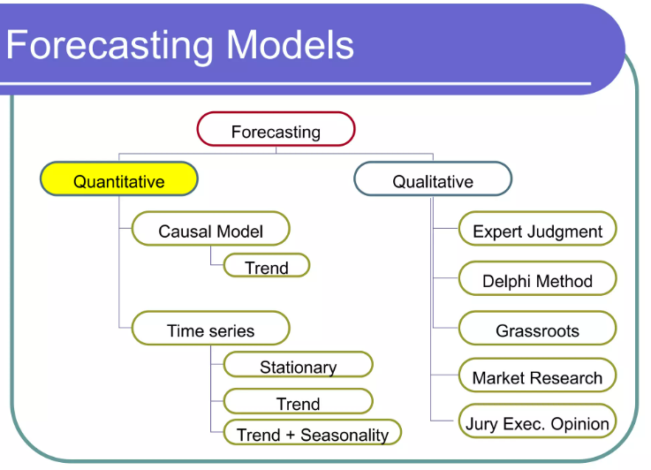Forecast means: “To estimate, conjecture, or imagine beforehand (the course of events or future condition of things). Sometimes with the clause as an object.” in dictionary.[10] Predicting something has always been inherently associated with artificial intelligence. Firstly it started with predicting next moves at chess and now AI is being used to make predictions about many different topics like; the stock market, economics, sales, legal, traffic, weather, disease, sports, natural disasters etc. In the context of “AI forecasting”, there are several methods. These are the methods:

**Naive Methods: It predicts that the next value of a series will be the same as the current value or the average of last two values. It is easy and simple to use but It doesn’t give accurate values for complex series. The limitations of naive methods highlight the importance of incorporating complicated techniques to achieve accurate forecasts.**



**Moving Average: Calculates the average of the last ‘n’ values of a time series.** Or uses weighted moving average and especially gives weight to recent values when calculating. This way the "moving average" becomes much more responsive and relatable.

**Regression Methods:** Predicts the dependent variable based on one, two or more independent variables. That is useful for identifying complex relationships between variables. Also there is one more sub-content which is ARIMA (Autoregressive Integrated Moving Average). Unlike others, ARIMA not only uses dependent variables but also uses past forecast errors to predict future values.

**Neural Networks(NN):** Just like the name of it NN is inspired by the human brain. It works like a neural. Each neural network takes the information, processes it and gives it to the next neural. The more neural networks and connections you have, the more complex relationships the NN can learn between the input and output data. This allows NNs to tackle challenging tasks like image recognition, speech recognition, and machine translation.

**diyagram, daire, çizgi, origami içeren bir resim

Açıklama otomatik olarak oluşturuldu**

Figure 1-Neural Networks [18]

**Qualitative Methods: These methods include: asking experts for their opinions anonymously on specific topics and developing multiple logical future scenarios. Qualitative methods are useful;** for forecasting complex events or situations with high uncertainty, when historical data is limited or unreliable, and for identifying potential risks and opportunities.

**Hybrid Methods:**Hybrid methods are created by combining two or more existing methods to best suit the specific need. We use hybrid models to leverage the strengths of both quantitative and qualitative approaches, resulting in a more comprehensive and nuanced understanding [11].

Although there are many prediction methods, machines have a weakness. Machines are bad at predicting rare events. Managers make decisions on mergers, innovation, and partnerships without data on similar past events for their firms. Humans use analogies and models to make decisions in such unusual situations. Machines cannot predict judgment when a situation has not occurred many times in the past [12].

Building upon our discussion of research methods, let us now explore strategies for their efficient implementation. Factors to consider include: the desired level of accuracy, the available data, the computational resources available and the expertise of the forecaster.

It is often necessary to experiment with different methods to find the one that provides the best results. We can briefly say that all of the methods we wrote here are being used in Legal Forecasting. But the most effective legal forecasting approach often involves a combination of quantitative and qualitative methods to gain a more comprehensive and nuanced understanding of the potential future legal landscape.

**3.2** **AI in Legal Forecasting**

For today we’ll be covering legal forecasting. Legal forecasting is kinda new to AI relative to other topics [13]. There are a few reasons for that. These are the complexity and multifacety of legal data, the evolving legal environment and lack of high-quality data available for training AI models. Despite these challenges, there are promising advancements in AI technology that could address them. And awareness of AI in the field of law is increasing day by day. AI is now poised to use computer and mathematical techniques to make the law more understandable, accessible, manageable, useful or predictable [1].

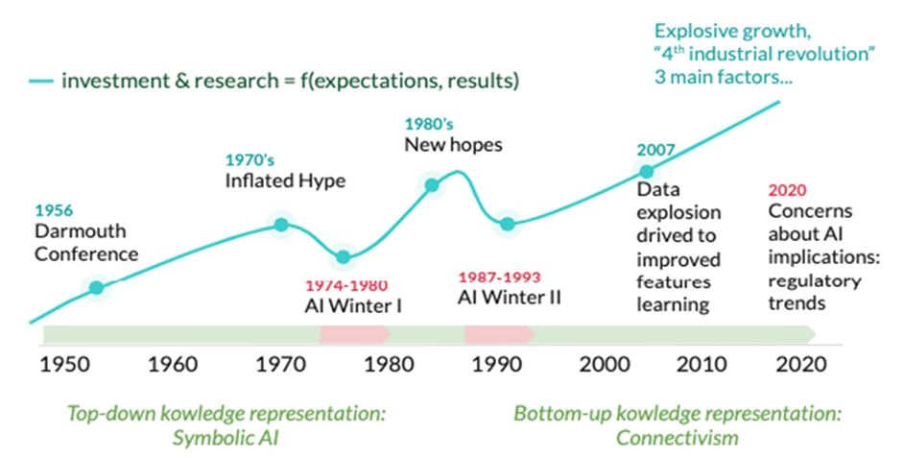

Figure 2-AI Winter

The International Conference on Artificial Intelligence and Law (ICAIL) has been showcasing applications of AI in law since at least 1987 [14]. Now let's go over the latest ICAIL report from 2022. As we can see in the figure-2 “AI and law” didn’t garner as much attention then as it does now. That period is named the “Winter of AI”. In the winter of artificial intelligence, distrust of AI and lack of knowledge have slowed the advancement of AI in the field of law. At that period McCarty underlined key questions which, in the last few years have characterized the research in AI and Law: How much of legal reasoning can be reduced to reasoning with rules? How is it possible to reason with cases at all? Is it possible to develop a computational theory of legal arguments?

Furthermore, in his 1993 paper, Bench-Capon presents two seemingly opposing viewpoints, which are complementary . These viewpoints, which would inform research in AI and Law over the following decades, frame the field in terms of rule-based and case-based reasoning,in other terms, knowledge systems and data systems. Capon's work thus helped to open the way for the end of the AI Winter and the beginning of the AI Summer in the AI and Law domain. Later than that the first attempts to make a hybrid system or to bridge the gap between “case-based” and “rule-based” systems were carried out.

From the analysis of the Artificial Intelligence and Law literature, we can conclude that although many theoretical conclusions have been reached in terms of artificial intelligence, there are still a limited number of large-scale applications in this field. Therefore, it is reasonable to wonder why this is happening. It is thought that the reason for this is due to the close relationship and dependencies between "Artificial Intelligence and Knowledge". Also one of the main reasons of the AI Winter was the insufficient amount of knowledge available. But in the ’90s, AI meets the Web and this changes everything. Since its beginning, the Web proved to be an extraordinary vehicle for knowledge creation and sharing. Thanks to the availability of large amounts of information in digital format, the Web appeared as a crucial component for the creation of AI systems. In this way the advent of the WEB ended the AI winter.

Nowadays we are clearly in the Summer of AI, in particular for AI and Law, with lots of opportunities to develop intelligent systems. In addition to that international organizations and regulatory bodies are attempting to foster public confidence by publishing guidelines and codes of ethics ( However, these initiatives are aimed at facilitating public trust rather than designing AI that is worthy of the public’s trust) [15]. With the current literature on Artificial Intelligence and Law and the massive development of the Semantic Web, we have many opportunities to take advantage of the expected dramatic data growth (Figure 4).

Therefore, the aim is to seize the opportunities of the next wave of data on artificial intelligence and legal approaches [14].

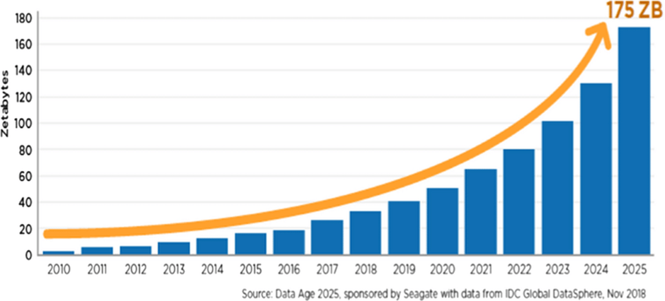

Figure 3-Data Growth

This long history of research and development has paved the way for the emergence of innovative NLP tools like “Adalethanım”, an AI-powered legal system developed in Türkiye in 2019. This platform assists with legal research, reduces workload, and provides easy access to legal information, highlighting the real-world impact of NLP on the legal sector. National and international studies further demonstrate the potential of NLP across various legal domains, including data analysis, document filing, and petition processing [16]. As can be understood from these developments, artificial intelligence is making very rapid progress. So how will AI affect the law of the future?

**4. LEGAL ETHICS AND ARTIFICIAL INTELLIGENCE**

The philosophical concept of ethics is generally used to define common truths and falsehoods. Just as ethics principles exist in every aspect of life, there are also professional rules and ethical principles in the field of law. Professional codes of conduct and ethical principles may vary across legal systems, countries, or cultures, yet fundamentally, they share common values. There are rules containing these ethical principles for legal practitioners, including prosecutors, judges, and lawyers. Some countries and international organizations are taking significant steps regarding the ethical governance of artificial intelligence. One of these, the OECD, has established five human-centric principles for AI, encompassing human benefit, respect for the rule of law, transparency, security, and responsibility. The utilization of artificial intelligence in traditional judicial processes is still in its infancy. The ethical dimension of this usage is a fundamental concern regarding how AI should be employed within the judicial system. Within this context, an important question arises: whether existing ethical standards are applicable to artificial intelligence or if a new ethical framework is necessary. Despite limited practical experiences, the extent of AI integration into judiciary remains uncertain. Given that current ethical standards were developed to address human-centric challenges like impartiality, the potential for AI to develop biases internally becomes significant. Observations indicate that AI can indeed develop biases based on data; for instance, the COMPASS software, an AI-based risk assessment tool accessing data of past offenders to predict recidivism, exhibited bias against African Americans [8]. Based on this data, the necessity for an ethical framework in the use of artificial intelligence in judiciary is determined. On the other hand, an ethical implication arising from the use of AI in the legal field relates to the competence of the attorney. The Model Rules of Professional Conduct, which undertake the ethical guidance for legal practitioners, emphasize the necessity for attorneys to provide adequate representation to their clients. In light of technological advancements in the legal domain, the concept of adequate representation is expanded to include familiarity with technology: "To maintain the requisite knowledge and skill, a lawyer should keep abreast of changes in the law and its practice, including the benefits and risks associated with relevant technology, engage in continuing study and education, and comply with all continuing legal education requirements to which the lawyer is subject." This context suggests that lawyers using AI programs to ensure adequate legal representation for their clients should have a fundamental understanding of how these AI programs operate and should not automatically accept the results generated by these programs. While the ethical consequences of using AI are debatable, avoiding the use of AI can also have ethical implications. As AI technology develops and becomes more prevalent in the legal field, abstaining from using AI in legal practice could significantly hinder providing clients with adequate legal representation. In summary, when used correctly, this technology can enhance the quality of legal services and expand access to justice. However, the ethical boundaries of artificial intelligence emphasize the need to strike a balance between legal professionals and machines [9].

**5. THE FUTURE OF AI IN THE FIELD OF LAW**

In the near future, before countries started to transform their institutions according to AI, countries should be ready for AI technology in some ways such as infrastructure and data, governance, skills and education, public services etc. Being unprepared causes variable problems such as: unemployment, inequality, safety issues, ethical issues. In addition to these, It can also create anxiety and uncertainty in society. Countries need to be prepared for the potential effects of artificial intelligence to prevent or minimize these problems.

In order to develop and progress studies in the legal field, case files globally, should be made accessible to researchers. In this way, the data set limit will be eliminated and more work can be done. The most important thing to consider when sharing case files is personal information and data about individuals. It would be more appropriate to present the data to researchers, taking into account cyber security risks when sharing data.

If we look at current studies, it can seen that AI has advanced a lot in the field of law in the last years. But there are conflicting predictions among experts about "how artificial intelligence will change our future." Some experts have stated that it is not ethically correct for an artificial intelligence to become a lawyer, that a robot has no say in human law, and that human emotions (such as empathy) are sometimes necessary in the field of law. Other experts on the other hand think they will take over all human jobs (full automation of labor) in 125 years [17]. In these cases some questions are being asked ; does the human judge argue only by deductive categories? Moreover, which role have the emotions in making decisions? Will a digital judge, emotionally neutral, be fairer than a human judge?

It is therefore natural to ask whether the studies on AI in the future will have to deal with emotions, intuitions and the automatic production of consciousness. Similarly, we should ask ourselves if the Web, as a knowledge infrastructure for AI, today emotionally neutral, will have to manage emotions. Currently, in fact, the information systems on the Web do not perceive user’s emotions and do not react accordingly. Therefore, it seems fascinating to foresee a further evolution of the Web in terms of the Web 5.0 or Emotional Web which will include human-machine interaction taking emotions into account. In this context, human beings will be able to communicate their emotions to systems capable of perceiving and processing them, consequently responding to their requests. In this scenario, the Law would be not an exception: not only rules and facts but also emotions can play a significant role in human-machine interaction. For example, the decision of an automatic judge could also be influenced by the emotional aspects, as it happens today in the interaction between humans. In this scenario, how will a human lawyer be able to persuade an automatic judge? [15]

**6. RESULT**

AI has revolutionized the legal field by regularizing document analysis and creation, as well as improving legal forecasting. AI-powered systems can analyze legal documents faster and more accurately than humans and that's really helpful for saving time and effort for legal professionals. Also, AI can scan huge amounts of data to find relevant information, improving legal research and providing access to the latest cases and case law. Moreover, AI automates document creation tasks such as drafting contracts and pleadings, so legal professionals having much more time for more complex works. This automation also increases accessibility to legal services by making them more affordable and accessible to individuals and businesses.

In legal forecasting, AI improves decision making (makes it easier to take hard desicions), reduces risks, helps to use time efficiently and also improves communication and collaboration. It can analyze past legal trends and predict future outcomes, helping legal professionals to make more informed decisions about lawsuit strategies, settlements, and other legal matters. By identifying potential risks and challenges early, AI can help legal professionals to reduce risks and avoid costly mistakes. AI can help legal professionals to allocate resources more effectively by predicting the likelihood of success in different cases and prioritizing tasks accordingly. AI makes it easy to communicate and collaborate between legal professionals by automatically creating reports and summarizing key information.

Examples of AI applications in legal research include Evisort, ROSS Intelligence, Adalethanım, and Luminance. These platforms assist with legal research tasks like generating draft contracts, answering legal questions, and identifying key provisions in contracts. Similarly, AI applications for document creation include Perfect NDA, LegalMation, Specifio, and LawGeex. These platforms automate document creation tasks like drafting NDAs, generating litigation documents, drafting patent applications, and verifying contracts for compliance.These are just a few examples of how AI is transforming the legal field. As AI technology continues to develop, we can expect even more innovative applications to occur, further improving the efficiency, accuracy, and affordability of legal services.

**REFERENCEE:**

[1] Surden, Harry. "Artificial intelligence and law: An overview." *Georgia State University Law Review* 35 (2019): 19-22.

[2]Turan, Tülay, Nazan Kemaloğlu, and Ecir Küçüksille. "Hukuk’ta Yapay Zeka: Çalışmalar ve Gelecek Öngörüleri." *Mehmet Akif Ersoy Üniversitesi Fen Bilimleri Enstitüsü Dergisi* 11.2 (2020): 246-255.

[3] Chakrabarti, Dipankar, et al. "Use of artificial intelligence to analyse risk in legal documents for a better decision support." *TENCON 2018-2018 IEEE Region 10 Conference*. IEEE, 2018.

[4] KARABEL, Emine Gökçe, and Dilek AYDEMİR. "Medeni Usul Hukukunda Yargılamanın Hızlandırılması ve Adalete Erişim Hakkı Bakımından Çevrimiçi Yargılama ve Yapay Zekanın Kullanımı." *Marmara Üniversitesi Hukuk Fakültesi Hukuk Araştırmaları Dergisi* 29.1.

[5] Ahmet, E. F. E. "Yargısal ve Hukuki Süreçlerde Yapay Zekâ Kullanan Araçlar Üzerine Bir Araştırma." *Bilgi Yönetimi* 5.1 (2022): 92-117.

[6] Ahmet, E. F. E. "Yargısal ve Hukuki Süreçlerde Yapay Zekâ Kullanan Araçlar Üzerine Bir Araştırma." *Bilgi Yönetimi* 5.1 (2022): 92-117.

[7] Turan, Tülay, Nazan Kemaloğlu, and Ecir Küçüksille. "Hukuk’ta Yapay Zeka: Çalışmalar ve Gelecek Öngörüleri." *Mehmet Akif Ersoy Üniversitesi Fen Bilimleri Enstitüsü Dergisi* 11.2 (2020): 246-255.

[8] YILMAZ, Oğuz Gökhan. "Yargı Uygulamasinda Yapay Zekâ Kullanımı-Yapay Zekâ Hâkim Cübbesini Giyebilecek mi?." *Adalet Dergisi* 66 (2021): 379-415.

[9] Nicole Yamane, *Artificial Intelligence in the Legal Field and the Indispensable Human Element Legal Ethics Demands*, 33 GEO. J. LEGAL Ethics 877 (2020).

[10] Oxford English Dictionary, s.v. “forecast, v.”, July 2023. <https://doi.org/10.1093/OED/9483232700>

[11] Song, H., Qiu, R. T., & Park, J. (2019). A review of research on tourism demand forecasting: Launching the Annals of Tourism Research Curated Collection on tourism demand forecasting. Annals of Tourism Research, 75, 353-356.

[12] Agrawal, A., Gans, J. S., & Goldfarb, A. (2018). Prediction machines: The simple economics of artificial intelligence. Harvard Business Review Press 103-110

[13] Turan, T., Kemaloğlu, N., & Küçüksille, E. (2020). Hukuk’ta Yapay Zeka: Çalışmalar ve Gelecek Öngörüleri. Mehmet Akif Ersoy Üniversitesi Fen Bilimleri Enstitüsü Dergisi, 11(2), 246-255.

[14] Francesconi, E. (2022). The winter, the summer and the summer dream of artificial intelligence in law: Presidential address to the 18th International Conference on Artificial Intelligence and Law. Artificial intelligence and law, 30(2), 147-161.

[15] Dlugatch, R., Georgieva, A., & Kerasidou, A. (2023). Trustworthy artificial intelligence and ethical design: public perceptions of trustworthiness of an AI-based decision-support tool in the context of intrapartum care. BMC Medical Ethics, 24(1), 1-16.

[16] <https://adalethanim.com/>

[17] Grace, K., Salvatier, J., Dafoe, A., Zhang, B., & Evans, O. (2018). Viewpoint: when will aI exceed human performance. EvidencefromaIexperts. JArtifIntellRes62, 729-754.

[18] Chen, Chi & Zuo, Yunxing & Ye, Weike & Li, Xiang-Guo & Deng, Zhi & Ong, Shyue. (2020). A Critical Review of Machine Learning of Energy Materials. Advanced Energy Materials. 1903242. 10.1002/aenm.201903242.